***How to open a service request using the ProCare and Facilities Service login:*SHIELDSITE**

You can access from any web connected PC or device – web link: <https://x44.emaint.com/> – feel free to add a shortcut to your desktop or browser for easy access. The weblinks on the Shields Infohub will also take you to this page.

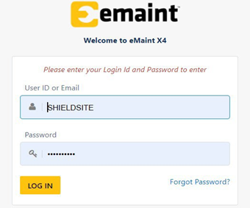Login and PW are the same for all Shields users and is not case sensitive.  
Login: SHIELDSITE  
PW: SHIELDSITE

To submit a service request, click on the **Work Order Requests**tab to access the home page

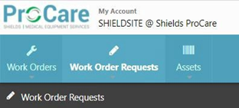It may also look like this: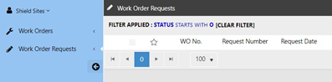Hover over the **+**plus sign on the upper right side of the page to select **ProCare Request**or **Facilities Request**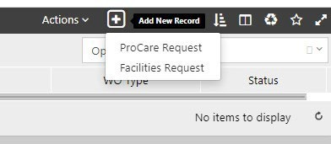If you do not see a **+**plus sign on the upper right side of the page to **Add New Record**and see something like the example below, click the **X**in the upper right corner or **Go to List**key (each highlighted in Red) to return to the **Work Orders Request**home page.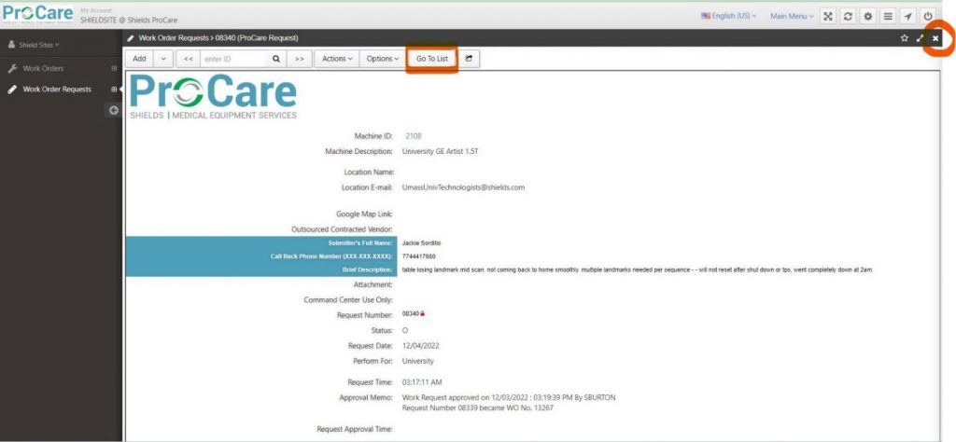Once available hover over the **+**plus sign on the upper right side of the page to select

**ProCare Request** or **Facilities Request**

For Facilities Service Requests please proceed below, for ProCare requests please go to pages 4 and 5

Select the Shields **Location Name**from the dropdown menu

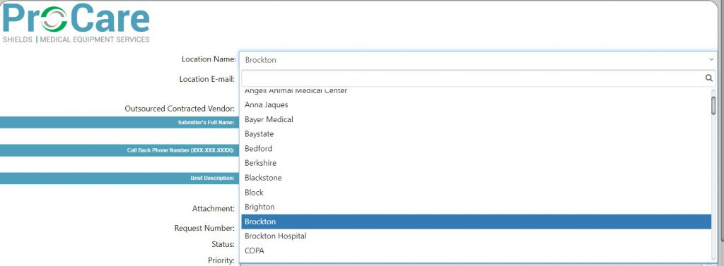Please fill in the remaining fields below highlighted in pink, and be as descriptive as possible in the **Brief Description** field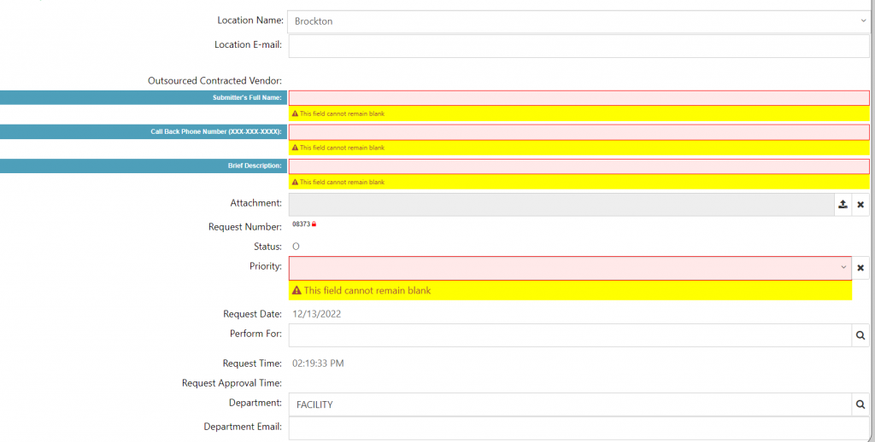Once finished, please click the **Save New Record**key and your request will be emailed to the Facilities Team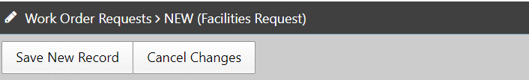In the next window that pops up, click the magnifying glass on the right to bring up the **Machine ID / Assets Look Up**search windowClick the drop-down menu in the **click here to load filter**window and select the desired site, you can also type keywords into the search field to look for the site name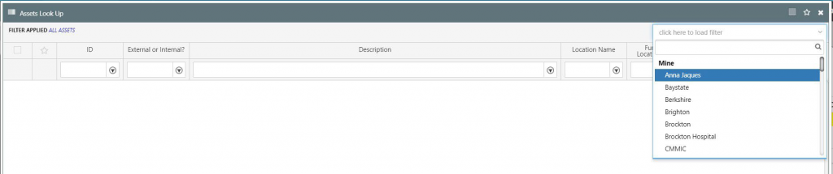Check the box of the desired equipment and click **Apply Changes**in the lower right corner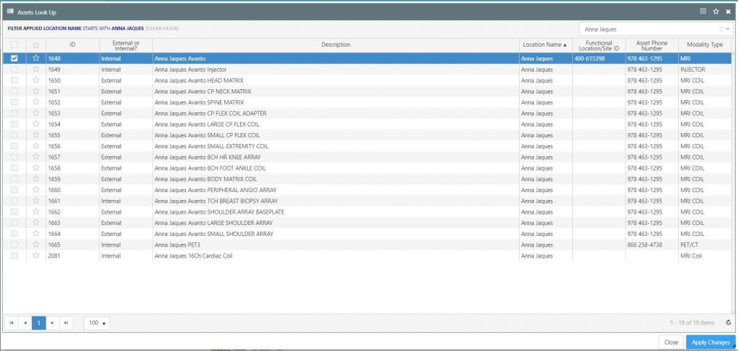Fill in the remaining highlighted fields and click **Save New Record**in the upper left corner to complete and launch the service request and ProCare will receive an email notification with this info in a few minutes.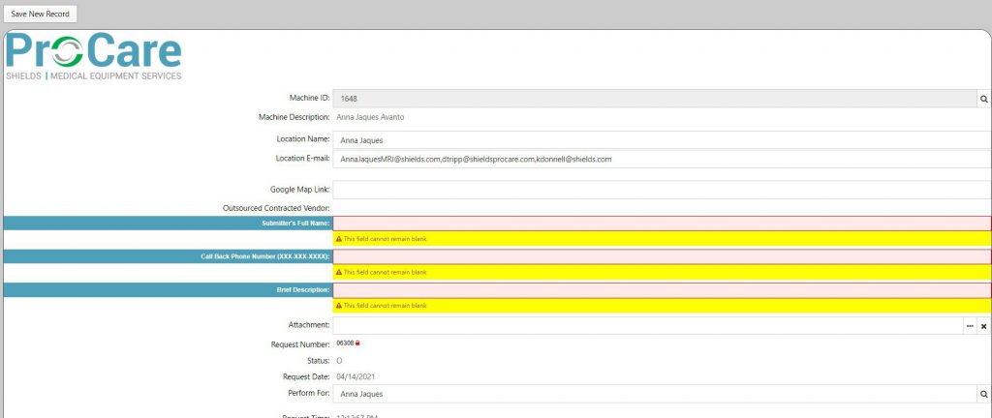

**How to review ProCare Service Records**

Hover over the **Work Orders**tab and then **Filters**, then **Global Filters**and click on the site you wish to view

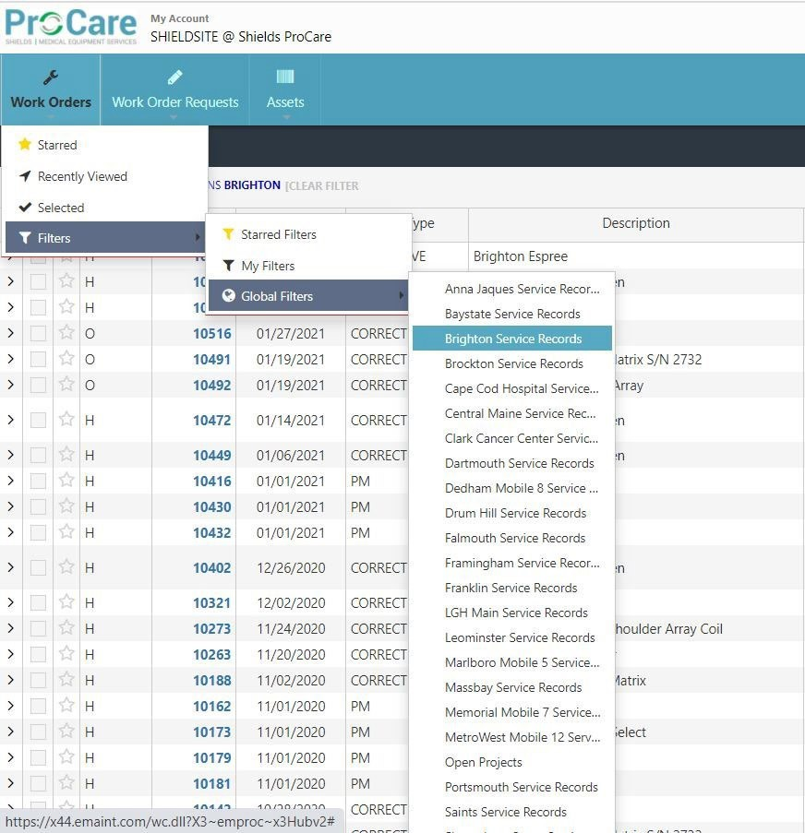The list will include all ProCare serviced equipment for the selected Shields location in chronological order and includes all service and PM work orders.

**Brighton Example:**

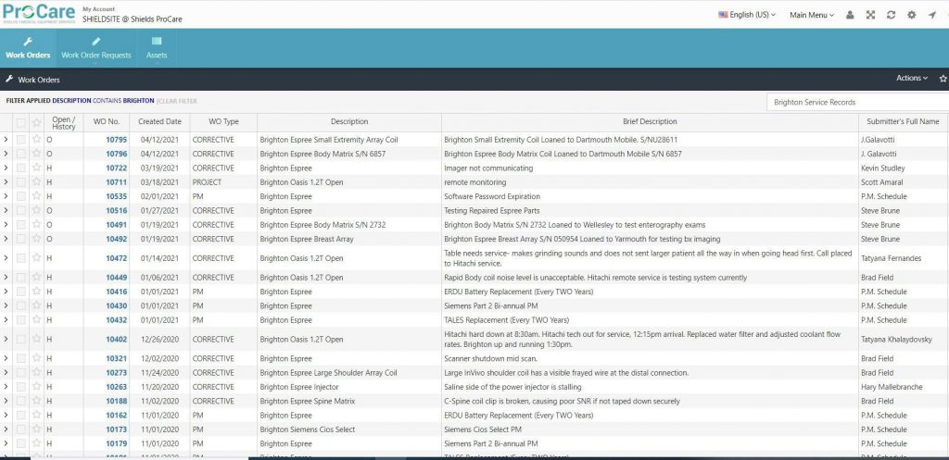

To view or print a work order in PDF format, left click the > (caret) symbol on the left of the desired work order and select **Print**, you may also select **View**, but this will not show the service notes/work performed on the work order:

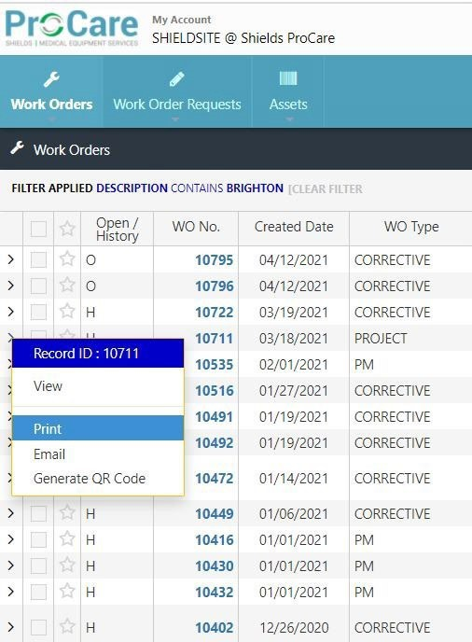To print multiple PM or Service Records on a single PDF, tick the box of each desired work order on the left-hand column and then click on the **Actions**drop down menu on the upper right portion of the window and select Print. You should receive a confirmation pop-up indicating you are now printing the following multiple work orders.