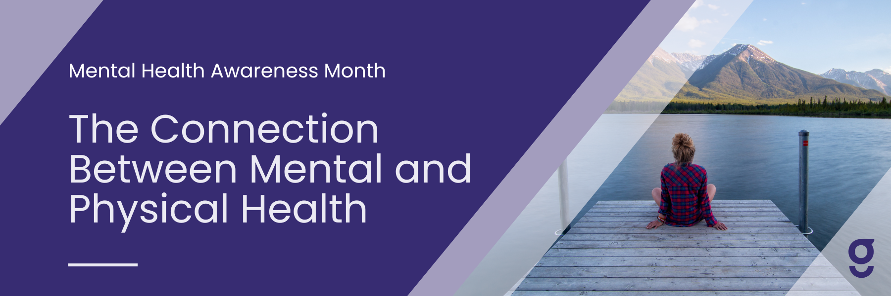

May is mental health awareness month. Mental health is a critically important topic, as the majority of U.S. adults face or will face things like high stress, anxiety, or depression. Mental health impacts more than just our thoughts or feelings, it’s also connected to physical health.

You may have experienced this yourself - have you been so stressed that you developed a headache? Have feelings of anxiety ever affected your digestive health? If so, you’re not alone - 76% of adults reported that they’ve faced stress so severe that it has affected their physical health.

While there’s been a lot of focus on mental health since the pandemic, we know that many people still are not actively seeking care. In fact, the majority of people who face mental health struggles are not seeking care. Why is this? And what does this have to do with physical health?

**A Focus on Physical over Mental Health**

[Between](https://pubmed.ncbi.nlm.nih.gov/14609780/) 55 to 75% of people with mental health challenges are more focused on physical health issues. Their pain, sleep issues, digestive issues, etc. are the top priority. This is understandable, as those symptoms can severely affect quality of life. However, this may further delay help with mental health.

When someone goes to the doctor or utilizes a resource to help with physical issues, there is rarely a focus on the mental health issue. In fact, when patients who had both back pain and mild depression went to primary care - 80% of depression diagnoses were [missed](https://www.ncbi.nlm.nih.gov/pmc/articles/PMC2837858/). This delays treatment and means feeling worse for longer.

Even if someone knows they have a mental health issue, they may not think it’s serious enough to seek care, such as therapy, even if it’s easy to access through benefits. Mental health challenges affect quality of life - sometimes as much, if not more - than physical health issues. Treatment leads to a big difference in quality of life.

**Mental Health Affects Physical Health**

Mental health conditions can lead to or make symptoms worse across pain, digestive issues, sleep, and more. In fact, depression can actually be a cause of back pain. It’s also very common to have both mental and physical health issues at the same time.

At Goodpath, we see this everyday. Our data shows that 73% of people that we treat with a physical condition, also have some level of anxiety or depression. While these members come in thinking about their physical condition, we are able to effectively help with both the physical and mental health conditions.

**Feel Better with Whole Person Care**

Seeking care with a whole-person approach is very impactful, as you receive help for both physical and mental health issues. When a whole person approach is used, more people with mental health issues get help, and their overall physical health improves more. Plus, that improvement is longer lasting.

Taking care of both your mental and physical health is key to lasting quality of life. It doesn’t have to be intimidating, especially when you see improvements in both areas. Treating mental and physical health together will lead to better health in all areas.